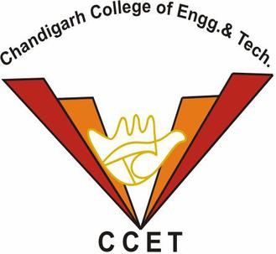

**CCET Inter-Year Sports Tournament, 2023**

In February-March 2023, CCET organized a series of inter-year sports tournaments that brought students from different academic years together in friendly competition. These events added an exciting energy to our campus, highlighting both the skills of our student athletes and the strong sense of community within our college.

This report contains the list of various sporting events that were conducted along with the list of winners in that respective sport.

|  |  |  |  |
| --- | --- | --- | --- |
| **Sr. No** | **Sport** | **Date** | **Student Organizer** |
| 1 | Cricket | 31-01-2023  01-02-2023 | Honey Sharma – Mechanical, 3rd Year |
| 2 | Volleyball | 01-02-2023 | Shubham Goyat – CSE, 3rd Year  Rahul Singh Rawat – CSE, 3rd Year |
| 3 | Chess | 02-02-2023 | Gopa Jeshwanth – CSE, 3rd Year  Atikant Rajpoot – Mechanical, 3rd Year |
| 4 | Football | 20-02-2023  21-02-2023 | Navdish – CSE, 3rd Year |
| 5 | Table Tennis | 21-02-2023  22-02-2023 | Vibhuti Bhardwaj – CSE, 2nd Year  Nirbhay Singh Sandhu – CSE, 2nd Year |
| 6 | Badminton | 19-03-2023  20-03-2023 | Chirag Sethi – CSE, 3rd Year  Rahul Yadav – CIVIL, 3rd Year |

**List of Winning Teams/ Winners**

* **CRICKET**

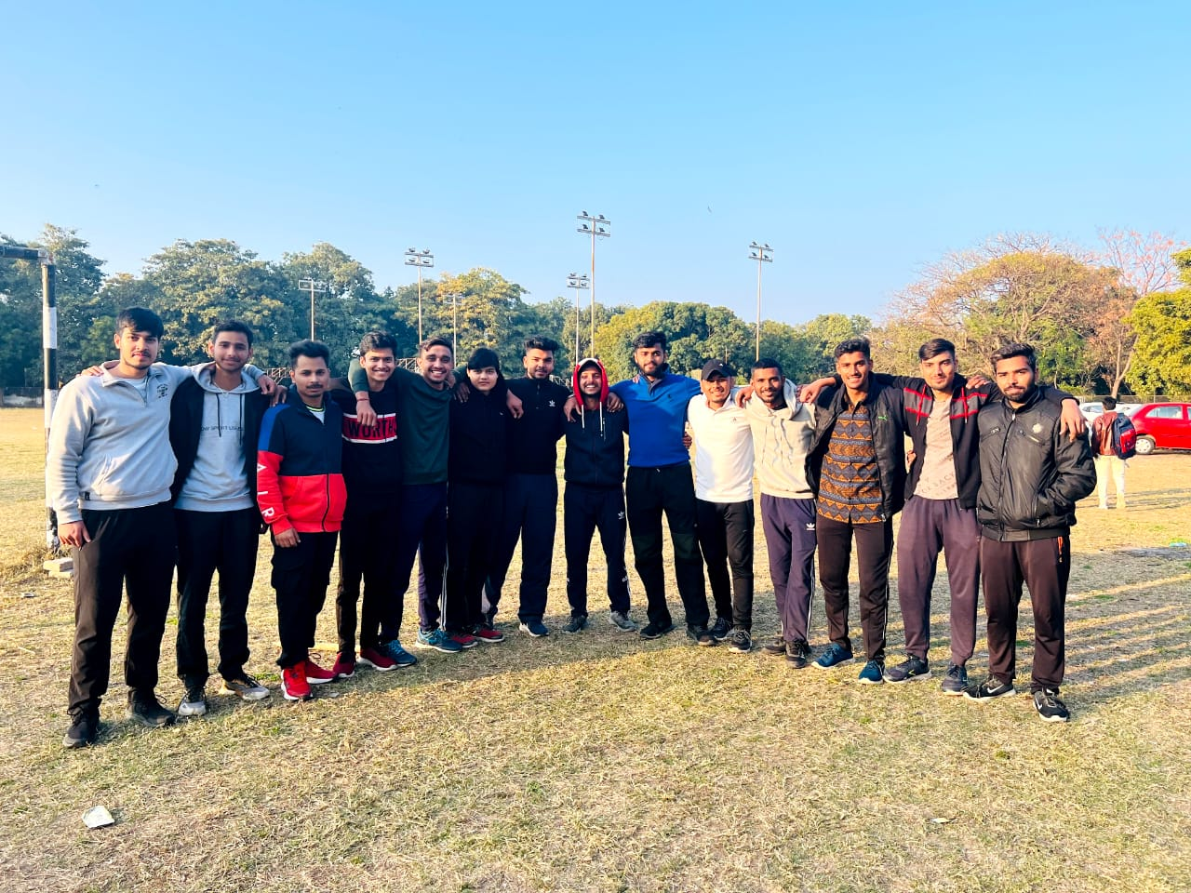3rd Year became the Winning Team in this tournament followed by the 2nd Year

Members of Winning Team were:-

|  |  |
| --- | --- |
| **Roll No.** | **Name** |
| CO20201 | Abhishek yadav |
| Co20115 | Honey Sharma (Captain) |
| CO20119 | Kuldeep Rathi |
| CO20114 | HariOm Bhatt |
| CO20145 | Vaibhav Dangwal |
| CO20109 | Atikant Rajpoot |
| CO20312 | Chirag Sethi |
| CO20133 | Sanchit Malhotra |
| CO20237 | Rahul Yadav |
| CO20565 | Utkarsh Sohal |
| CO20111 | Bhanu Partap Singh |
| CO20370 | Vikrant Sharma |
| CO20213 | Barjesh kainth |
| CO20230 | Nischal Lamdharia |

* **VOLLEYBALL**

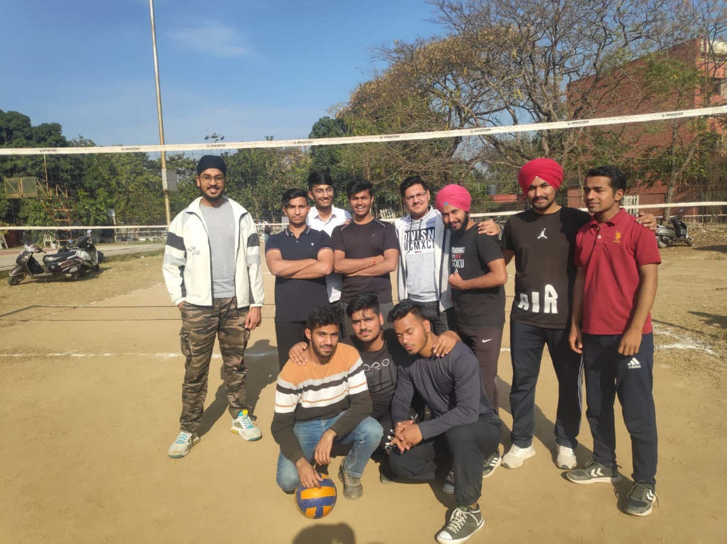3rd Year became the Winning Team in this tournament followed by the 2nd Year

Members of Winning Team were:-

|  |  |
| --- | --- |
| **Roll No.** | **Name** |
| CO20354 | Shubham Goyat (Captain) |
| CO20341 | Rahul Singh Rawat |
| CO20333 | Munish Sharma |
| CO20310 | Chaitanya Sharma |
| CO20331 | Manjot Singh |
| CO20334 | Navdish |
| CO20332 | Manraj Singh |
| CO20344 | Rishi Dhiman |
| CO20347 | Satyam Aggarwal |
| CO20323 | Iqman Singh Bhatia |
| CO20346 | Saksham Kaushik |
| CO20316 | Divyansh Aggarwal |

* **CHESS**

Many students actively participated from in Chess Tournament.

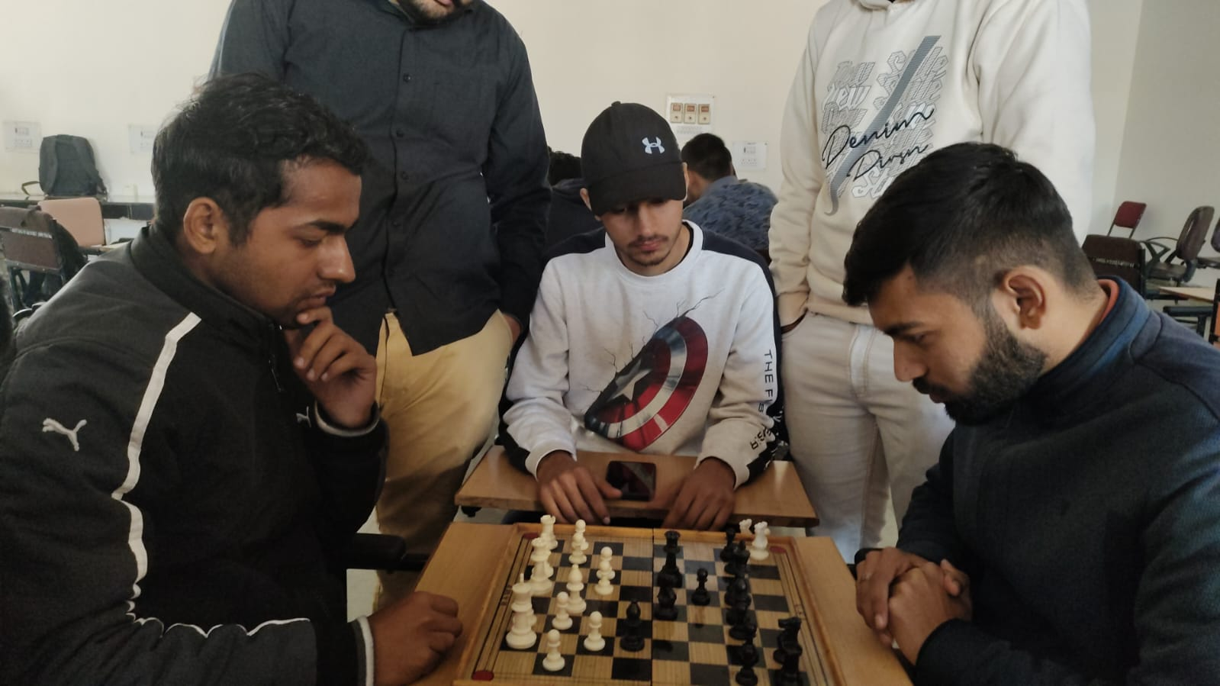

The Players who came out on top were:

|  |  |  |  |  |
| --- | --- | --- | --- | --- |
| **Roll No.** | **Name** | **Year** | **Branch** | **Position** |
| LCO21256 | Ansh Pratap Singh | 2nd | CIVIL | FIRST |
| CO22518 | Dhruv Sharma | 1st | ECE | SECOND |
| CO21365 | Siddharth Vaghmare | 2nd | CSE | THIRD |
| CO22108 | Owais Qamer | 1st | MECH | THIRD |

* **FOOTBALL**

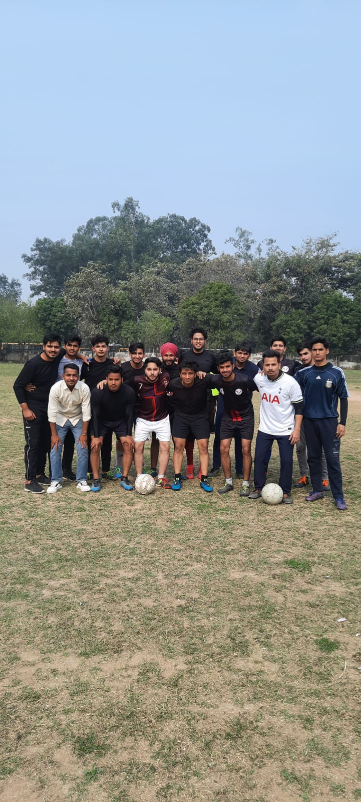3rd Year became the Winning Team in this tournament followed by the 1st Year

Members of Winning Team were:-

|  |  |  |  |  |
| --- | --- | --- | --- | --- |
| **Roll No.** | **Name** |  | **Roll No.** | **Name** |
| CO20334 | Navdish (Captain) |  | CO20331 | Manjot Singh |
| CO20346 | Saksham Kaushik |  | CO20517 | Dev Jugran |
| LCO20579 | Rhythm Bisht |  | CO20111 | Bhanu Pratap |
| LCO20580 | Rishav Bharadwaj |  | CO20354 | Shubham Goyat |
| CO20543 | Prakhar Singh Guleria |  | CO20333 | Munish Sharma |
| CO20539 | Nikhil Sharma |  | CO20347 | Satyam Aggarwal |
| CO20557 | Shaurya Singh |  | CO20316 | Divyansh Aggarwal |
| MCO20263 | Shubhang Sharma |  | CO20202 | Adit Malik |
| CO20341 | Rahul Singh Rawat |  | LCO20581 | Shivansh Sharma |
| LCO20582 | Varunesh Sharma |  | CO20323 | Iqman Singh Bhatia |

* **TABLE TENNIS**

Many students participated in the Table Tennis Inter year tournament in both Singles and Doubles Categories.

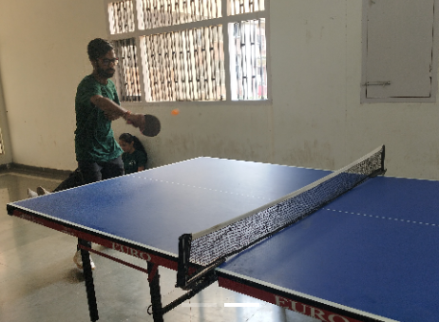

The Players who came put on the top were:

**SINGLES**

|  |  |  |
| --- | --- | --- |
| **Roll No.** | **Name** | **Position** |
| CO21346 | Nirbhay Singh Sandhu | FIRST |
| CO21314 | Charan Kamal Singh | SECOND |
| CO22302 | Abhavya Muku | THIRD |

**DOUBLES**

|  |  |  |
| --- | --- | --- |
| **Roll No.** | **Name** | **Position** |
| CO21314 | Charan Kamal Singh | FIRST |
| CO21368 | Vibhuti Bhardwaj |  |
| CO21346 | Nirbhay Singh Sandhu | SECOND |
| CO22109 | Shiven Padarwal |  |
| CO20312 | Chirag Sethi | THIRD |
| CO20327 | Krishna Goyal |  |

* **BADMINTON**

The Badminton Tournament was conducted in Sports Complex, Sector-7, Chandigarh.

Many students actively participated in the tournament across these 5 categories

* Men’s Singles
* Women’s Singles
* Men’s Doubles
* Women’s Doubles
* Mixed Doubles

Some Pictures of the day:-

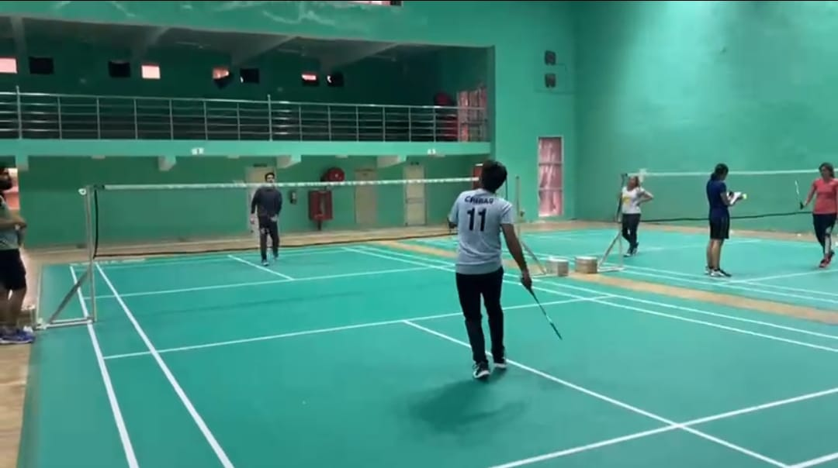

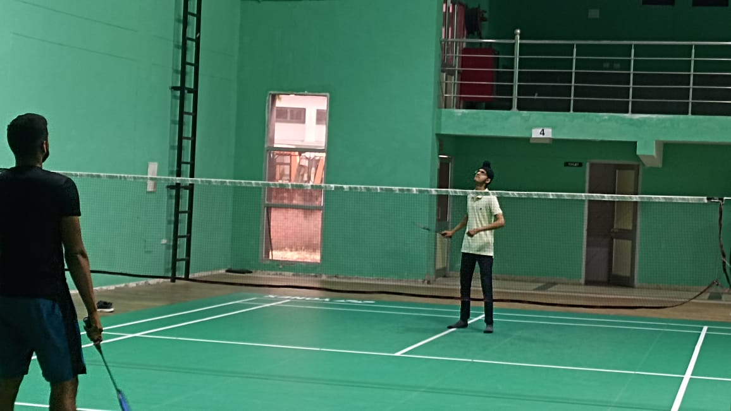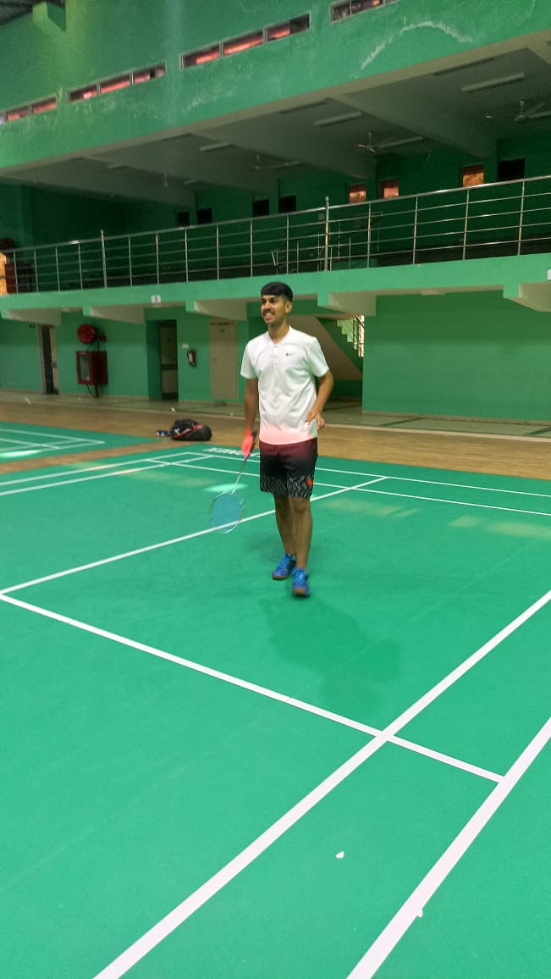

Winners in various categories were:

**MEN’S SINGLES**

|  |  |  |  |  |
| --- | --- | --- | --- | --- |
| **Roll No.** | **Name** | **Year** | **Branch** | **POSITION** |
| MCO21580 | Himanshu Kashyap | 2nd | ECE | FIRST |
| CO20237 | Rahul Yadav | 3rd | CIVIL | SECOND |
| CO21205 | Amit sihag | 2nd | CIVIL | THIRD |

**MEN’S DOUBLES**

|  |  |  |  |  |
| --- | --- | --- | --- | --- |
| **Roll No.** | **Name** | **Year** | **Branch** | **POSITION** |
| CO19330 | Jagteshvar Jot Singh | 4th | CSE | FIRST |
| CO19565 | Vipul Kumar | 4th | ECE |  |
| CO20312 | Chirag Sethi | 3rd | CSE | SECOND |
| CO20237 | Rahul Yadav | 3rd | CIVIL |  |
| CO21205 | Amit sihag | 2nd | CIVIL | THIRD |
| CO21213 | Dinesh | 2nd | CIVIL |  |

**WOMEN’S SINGLES**

|  |  |  |  |  |
| --- | --- | --- | --- | --- |
| **Roll No.** | **Name** | **Year** | **Branch** | **POSITION** |
| CO21513 | Ananya Sheoran | 2nd | ECE | FIRST |
| CO21520 | Arshia | 2nd | ECE | SECOND |
| CO19131 | Kritika Bhatt | 4th | Mech | THIRD |

**WOMEN’S DOUBLES**

|  |  |  |  |  |
| --- | --- | --- | --- | --- |
| **Roll No.** | **Name** | **Year** | **Branch** | **POSITION** |
| CO21513 | Ananya Sheoran | 2nd | ECE | FIRST |
| CO21520 | Arshia | 2nd | ECE |  |
| CO19131 | Kritika Bhatt | 4th | Mech | SECOND |
| LCO21598 | Pranjal Agrawal | 2nd | ECE |  |

**MIXED DOUBLES**

|  |  |  |  |  |
| --- | --- | --- | --- | --- |
| **Roll No.** | **Name** | **Year** | **Branch** | **POSITION** |
| CO19330 | Jagteshvar Jot Singh | 4th | CSE | FIRST |
| CO21513 | Ananya Sheoran | 2nd | ECE |  |
| CO20312 | Chirag Sethi | 3rd | CSE | SECOND |
| CO21520 | Arshia | 2nd | ECE |  |
| CO21205 | Amit sihag | 2nd | CIVIL | THIRD |
| CO22223 | Vartika Saxena | 1st | CIVIL |  |

**END OF REPORT**